# **CSCU9N6 Report**

# **2626628**

**Plot:**

In the game, ninja must race through the tile map and collect as many coins as possible without colliding to the hurdles. The worlds are full of enemies and spikes, and lavas. If ninja touches an enemy, he dies. If ninja falls on spikes or on lava, ninja dies.

In the first level ninja faces spikes and other enemies. Ninja should aim to reach the flag safely collecting coins. Once ninja reaches the flag then the game loads to level 2.

This version of the game only contains 2 levels. Ninja faces lava and other enemies in the second level. Ninja need to avoid lava and enemies in this level and collect as many coins as possible once ninja reaches the flag then the game is over.

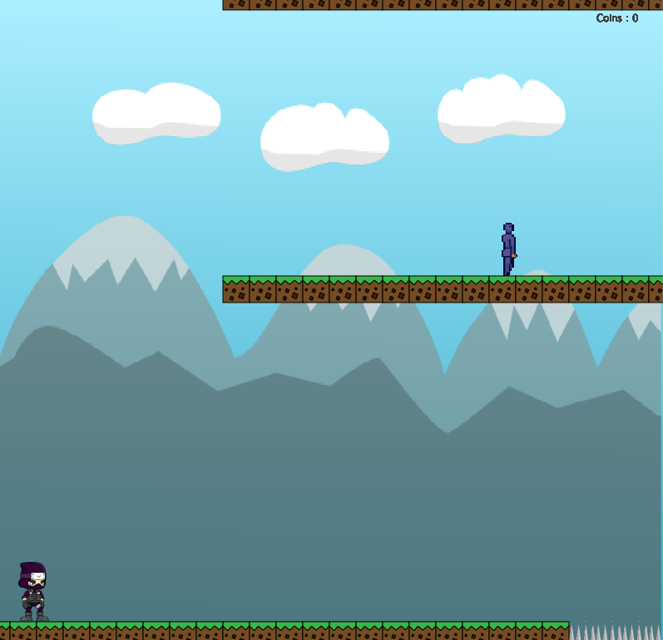

.

* The user can use the keys from the keyboard to make the player move, jump, attack:
  + Left/Right Arrow = Walk Left/Right
  + Up = Jump
  + Up + Up = Double Jump
  + Enter = Reset
  + Esc = Exit

**Explanation:**

I named my game as “Ninja runner**”.** I have implemented a basic java 2d game tile map based (similar to Mario). I have taken my sprites from “OpenGameArt.Org”.

My player is controlled with the up, right and left arrows from the key board. I have created two text files “map1.txt” and “map2.txt” for 2D tile maps with 2 levels. The aim of the player is to reach the flag while collecting has many coins as possible. I have added coins in the tile maps and if player collects one coin then player score is increased by 100. To achieve this, I have implemented “checkScoreCollision” method which increments the player score.

I have loaded some enemies in level 1 and 2. Also, I have added spike tiles in level 1 and lava tiles in level 2. To reset the game, need to press “enter key”.

I have added some sounds for background music, collecting the coins and dead music. I have taken in sounds from “freesound.Org”. Sprite class and animation class are reusable. I can add has many sprites and load animations to them.

**Functionality implemented Successfully:**

* My tile maps are loading very well.
* My player and enemy’s animation are fine.
* InitialiseGame is working well and setupEnimies are loading well.
* handleSpriteCollision, handleTilemapCollisions, enemyCollison and checkScoreCollision are working well.
* Key events and mouse events are working well.

**Improvements:**

* Sprites animation can be better.
* Background images and sound effects can be better.
* Better tile collisions.

**Further functionality can be added to the game:**

This game has 2 stages. Stage1(Mountain) and Stage2(Ice Land).

Based on my prototype, some of the functionalities that I would like to add are:

* Score (score points for killing enemies)
* This game can be improved by giving the gamer to choose the player (Sprite) from choice of few sprites.
* Game can be made harder by adding enemies in the game attack the player by throwing weapons.
* Improve background animations with more quality, add more custom sounds for each action of each sprite.
* Level selection function.
* Save/load(resume from where the gamer stopped) game function.
* Menu screen, to start the game, pause and quit the game.
* More levels can be added with different themes like under water, deserts, space etc.

Due to time constraints I have implemented the best possible for me in this game. I am happy with my game but improvements can be done. I made my game based on my personal gaming experience.

**Applications-Tools Used:**

* <https://opengameart.org/art-search?keys=ninja>
* <https://freesound.org/people/ADnova/sounds/434839/>
* <https://instantsprite.com/>
* Adobe Illustrator
* Scratch Desktop